Assignment 1 – User Needs Analysis (70 points)

|  |  |
| --- | --- |
| **Due date:** | See CANVAS for submission deadline and instructions. |
| **Objective:** | The goal of this assignment is to define the project scope, understand the needs of potential users, and gain deeper knowledge of the design problem through discussions with technical experts. |

1. Project Scope (/5 points)
2. **Problem Statement**. Describe the goal of this project in your own words (2-3 sentences, not copied from the project description) (/2 points)

The University of Utah’s Mechanical Engineering Department will soon be implementing a new automation course where students will learn how to use Programmable Logic Controllers. This course will offer a lab where students will be able to interact with a fully automated robotic process line controlled by PLCs. This process line will initially be too complex to teach students about the basics of PLCs. Our group is tasked with creating a PLC Trainer platform, capable of teaching students the basics of PLC control. This PLC Trainer should have an interactive platform with various buttons, switches, HMI and indicators that will interact with a wind tunnel module, a VFD & motor module, and a pneumatic switch module.

1. **Scope.** Complete the following table detailing the required project scope, optional additional scope, and elements outside the project scope. Rank items in the “optional additional scope” column in order of priority (1 = highest priority additional scope item) (/2 points).

|  |  |  |
| --- | --- | --- |
| Must be part of scope | Optional next steps (rank) | Not included in Scope |
| * 1 PLC trainer platform (control panel, HMI, buttons, switches, indicators, compatible with industry regulations, has examples of sinking and sourcing for input and output devices, analog and digital I/O, serial communication, network communication, wiring diagram) * 1 wind tunnel module to teach analog sensing and control (P&ID diagram, wiring diagram, set point control +- 10% errors: volumetric flow rate control TBD & air temperature control TBD) * 1 VFD & motor module to teach network and serial communications (P&ID diagram, wiring diagram) * 1 Pneumatic switch module to teach digital sensing and control (P&ID diagram, wiring diagram) * 1 Cognex camera module to teach network and serial communications (Integration: position/ orientation & color) * Documentation/drawings/bill of materials to reproduce product. | * Advanced Cognex camera integration (defect detection, barcode reading, gliff registration) * Interaction/communication with lab robot arms | * Additional modules * Senior design Lab copy * Additional units of the trainer and modules for the class |

1. List all possible users of your design. Be sure to include both “mainstream” and “extreme” users, as discussed in class (/1 points).

|  |  |
| --- | --- |
| Mainstream Users | Extreme Users |
| * Students * Teaching Assistants * Professors * Lab Staff | * Elderly students, TA’s, Professors, Lab Staff * Students, TA’s, Professors, and Lab Staff with disabilities (Needs to be Easily Accessible and Configurable) * Foreign Exchange/Non-English-Speaking Students, TA’s, Professors, and Lab Staff |

1. User Interviews (/20 points)

Conduct interviews with **two** potential users of your design. Due to the importance of gathering outside input in the early stages of design, project team members and team faculty advisors do not qualify as users for this assignment. Complete the following table for each user interview. Provide detailed notes from your interview in the Appendix to this assignment, *including a list of questions/materials prepared by design team in advanced of interview* (part E).

1. User #1 (/10 points)

|  |  |
| --- | --- |
| Interviewee: | Mikael |
| Interviewer(s): | Brandon Lim, Gavin Sueltz, Kelton McGrath |
| Interview location/time/duration (/1 point for rows 1-3): | WEB 2250 – 5pm – 15min |
| Explain why the interviewee is a good candidate for understanding user needs (3-5 sentences)(/1 point): | Mikael has experience working with PLCs on his senior design project. This was his first introduction to PLC’s, so he is very familiar with learning about PLCs for the first time. Aside from his experience with PLCs, his interest in robotics and automation will play a major role in identifying what students with an interest in PLCs will want from a PLC trainer. |
| What technique(s) that we learned in class did you use in conducting this interview? See Chapter 3, Table 1 for documentation to include with your technique(s) (/1 point) |  |
| Summarize your key findings from the interview (3-5 bullet points) (/3 points): |  |

Additional points:

* List of questions/materials prepared by design team in advanced of interview (include in Appendix) (/2 points)
* Detailed interview notes provided in Appendix (/2 points)

1. User #2 (/10 points)

|  |  |
| --- | --- |
| Interviewee: | Jensen Coumbs |
| Interviewer(s): | Shey Dilloway, Kelton McGrath, Gavin Sueltz |
| Interview location/time/duration (/1 point for rows 1-3): | MEK Tutoring Center - 2:00pm 9/10/24 – 15 Minutes |
| Explain why the interviewee is a good candidate for understanding user needs (3-5 sentences) (/1 point): | Jensen is an undergraduate student with no experience in PLC’s but with an interest in learning about them. He is interested in robotics and controls, which are tools that can be controlled by PLC’s. Jensen is a good candidate to know what students with no experience with PLC’s would like when it comes to a training platform for PLC’s. By interviewing Jensen, our team can identify what students with no experience in PLC’s know and don’t know about how they work. |
| What technique(s) that we learned in class did you use in conducting this interview? See Chapter 3, Table 1 for documentation to include with your technique(s) (/1 point) | The technique used was the “five whys” technique. This style was chosen as it allowed us to probe the interviewee for more in depth answers. After |
| Summarize your key findings from the interview (3-5 bullet points) (/3 points): | * Students are not taught the intricacies of combining theory and technical abilities in the current curriculum, this trainer could be a good opportunity to bridge this gap * It would be useful to learn some of the more mundane things about PLCs, such as data transfer * Wiring and physically connecting the different components of the PLC would be extremely beneficial for students * Having simple user inputs (switches, buttons etc.)  in combination with simple PLC outputs (LEDs, simple pneumatics etc.) would be beneficial for students to learn ladder logic with |

Additional points:

* List of questions/materials prepared by design team in advanced of interview (include in Appendix) (/2 points)
* Detailed interview notes provided in Appendix (/2 points)

1. Technical Expert Interviews (/10 points)

Conduct an interview of **one** technical expert that can provide insight into your design challenge. Technical experts may have knowledge related to engineering challenges specific to your design, or particular applications of your design. Your faculty advisor may NOT be your technical expert, but can help you identify a relevant technical expert. You are encouraged to find a technical expert that is NOT a faculty member in the mechanical engineering department. Complete the following table for your interview. Provide detailed notes from your interview in the Appendix to this assignment, *including a list of questions/materials prepared by design team in advanced of interview* (part E).

1. Technical Expert (/10 points)

|  |  |
| --- | --- |
| Interviewee: | Patrick Russo |
| Interviewer(s): | Anthony Russo |
| Interview location/time/duration (/1 point for rows 1-3): | Phone call – 6:00 PM 9/10/24 – 30 Minutes |
| Explain why the interviewee is considered a technical expert for your project (3-5 sentences) (/1 point): | Patrick Russo is an engineer for NovaTech Automation which specializes in electrical substation automation and control systems. NovaTech utilizes PLCs as a controller in their work. Patrick makes hiring decisions for the company based on candidate PLC experience and knowledge. He will be a good candidate to interview due to his grasp on industry standards concerning PLCs. |
| What technique(s) that we learned in class did you use in conducting this interview? See Chapter 3, Table 1 for documentation to include with your technique(s) (/1 point) |  |
| Summarize your key findings from the interview (3-5 bullet points) (/3 points): |  |

Additional points:

* List of questions/materials prepared by design team in advanced of interview (include in Appendix) (/2 points)
* Detailed interview notes provided in Appendix (/2 points)

1. User Needs Testing (/20 points)

The goal of user needs testing is to place yourself in the “shoes” of your prospective users, and see the design problem from their perspective. User needs testing activities are also known as “empathy-oriented prototypes”, because they help you to experience the design problem first-hand.

Examples of user needs testing include but are not limited to:

- Physical tests that help you understand design constraints (e.g. size, weight, etc.);

- Spending time with users and documenting their experiences (e.g. photo-journal);

- Extensive background research on the design environment (if you can’t directly go “into the field”);

- Simulating the user environment and challenges;

- Experimenting with existing design solutions or related devices and documenting their advantages/limitations;

One “large” user needs tests or several “small” tests are acceptable, as long as multiple insights into user needs can be gained (see question 3).

1. Describe the goal of your user needs testing in one paragraph (e.g. what are you trying to learn?) What user group(s) are you seeking to understand? (/4 points):

The goal of our user needs testing is to define the accessibility of the PLC Lab Trainer in terms of the rough dimensions, weights, and locations. We are seeking to understand the limitations of our mainstream and extreme users. Due to the modular nature of the PLC modules, we want to make sure that they are easily relocatable. When sitting down at a lab station, we want to make sure that the users can interact fully with the PLC trainer platform/control panel without having to strain or overly exert themselves to reach interactive devices. We also want to know how the equipment will interact with the lab room itself, specifically; how much space is allotted for one station? What will storage of the stations look like? What is the proximity of each station to a power supply outlet?

1. Describe what you did for your user needs testing exercise in one paragraph (e.g. activities/tasks performed, prototyping conditions/set-up, etc.) (/4 points).

For our user needs testing, we did a focus group exercise between our design project members to parse out what would be helpful in an interactive lab setup from a student's perspective. We discussed aspects of a lab setup that would engage or disinterest students. To investigate the layout of an effective lab trainer platform, we went to the mechatronics lab and dimensioned a single station from the perspective of a student sitting down. This is where we learned the advantages and disadvantages of the locations of an HMI, I/O interactions and platform dimensions. We also observed the testing machines in the TFES lab to understand proper machine setup and interface. To define the location boundaries of our platform, we toured the lab that the trainers will be used in and actively took notes on constraints such as room ergonomics and outlet locations.

1. Summarize the key findings from your user needs testing experience (6-10 bullet points) (/6 points):

* From a student’s perspective a simplistic lab training platform will be more inviting for beginners to engage with.
* The trainer platform and the modules will need to fit within a volume of 36 inches in width, 18 inches in depth and 24 inches in height when the students are conducting a lab.
* To comply with industry standards of lockout and tagout procedures, only one power cord will be acceptable to transfer power to the system from the outlet.
* To comply with the volumetric dimension boundaries, we will have to design the platform-module interface to where the module will rest on top of the platform.
* To allow easy accessibility to I/O plugins and connections, the PLC or terminals will need to be in the front of the platform, not the sides or back.
* Transparent acrylic panels should be used as much as possible to allow students to investigate the wired connections within the platform.
* Any power connections need to be securely and safely routed to comply with industry standards to protect all users.

1. Include detailed notes/photos/videos from your testing experience in the Appendix of this assignment (or upload as supplementary files on Canvas) (/6 points)
2. Prioritized List of User Needs (/15 points)
3. Create a bulleted list of user needs. This list should come from your interview notes and notes from your user needs testing. (/12 points)
4. Add rankings to the each need in the list created in part 1. Add the rankings to the list. Describe the ranking system you are using (i.e. what does 1, 2, 3, etc. mean?). (/3 points)

1. Appendix (points included under part D, User Needs Testing)

Include the following supplementary material in the Appendix to Assignment 1:

1. Notes from user interviews. Include questions/other materials prepared by design team for interview.
2. Notes from technical expert interviews.
3. Notes, photos, and/or videos documenting your user needs prototype.

Questions for Mika

1. In your opinion, what are the essentials a student must learn to begin using PLCs?
2. Is there a specific model of PLC you think students should learn on?
3. What field devices would be most valuable for a student to use?
4. What are some of the more difficult things to understand about PLCs?
5. What should be easily accessible on this trainer?
6. How do you picture yourself interacting with the PLC Trainer? What buttons, switches, and indicators would you imagine?

Notes from Mikas interview

* Different methods of inputs (voltage/current), signal conditioning, how to build P&ID Diagram, understanding different phases of power are very important aspects of PLCs to learn.
* BRX PLC is a good PLC for students to learn on.
* Load cells, Temperature sensors, Stepper Motors, VFD are valuable field devices for students to learn how to use.
* Choosing field devices that are compatible with the PLC and power is something that is difficult for students to learn and understand.
* An accessible hookup to computers is something that students should have access to with a PLC platform.
* Usage of on and off switches, dials, buttons, and lights to control the modules after hooking up hardware and programming logic is what Mika envisions a PLC platform to accomplish.

Questions for Jensen Coumbs

1. What interests you about PLCs and what would you like to learn about them?
2. What do you already know about PLCs?
3. How do you envision yourself using a PLC system in the future?
4. What field devices would be most interesting to control using a PLC system?
5. What is the most intimidating thing about PLCs?
6. How do you picture yourself interacting with the PLC Trainer? What buttons, switches, and indicators would you imagine?

Notes from Jensen’s interview

Questions for Patrick Russo

1. What are some common challenges those learning about PLC’s face?
2. What are the most important aspects of PLC’s that new graduates should be familiar with?
3. What initial challenges do you see in this project?
4. What features do you think would be most useful to students?
5. What interface configuration would most closely simulate what is used in the industry?

Notes from Patrick’s interview

* Programming is the most common challenge when it comes to learning about PLC’s. Solving logic, series vs parallel execution, brand differences, and troubleshooting code are the main sources of programming challenge.
* New graduates should be familiar with the application of PLCs, the difference between PLCs and microcontrollers, PLC capabilities, option cards, and programming of PLCs if they are looking to go into PLCs in industry.
* Sourcing proper and compatible equipment and option cards are the two initial challenges that he sees with our project.
* Focus on the teachings of different inputs (4-20mA, -10-+10V) should be emphasized in the platform.
* Mounted LED indicators, error codes, and real time data are important indicators to include on the platform.

User Needs Testing Photos

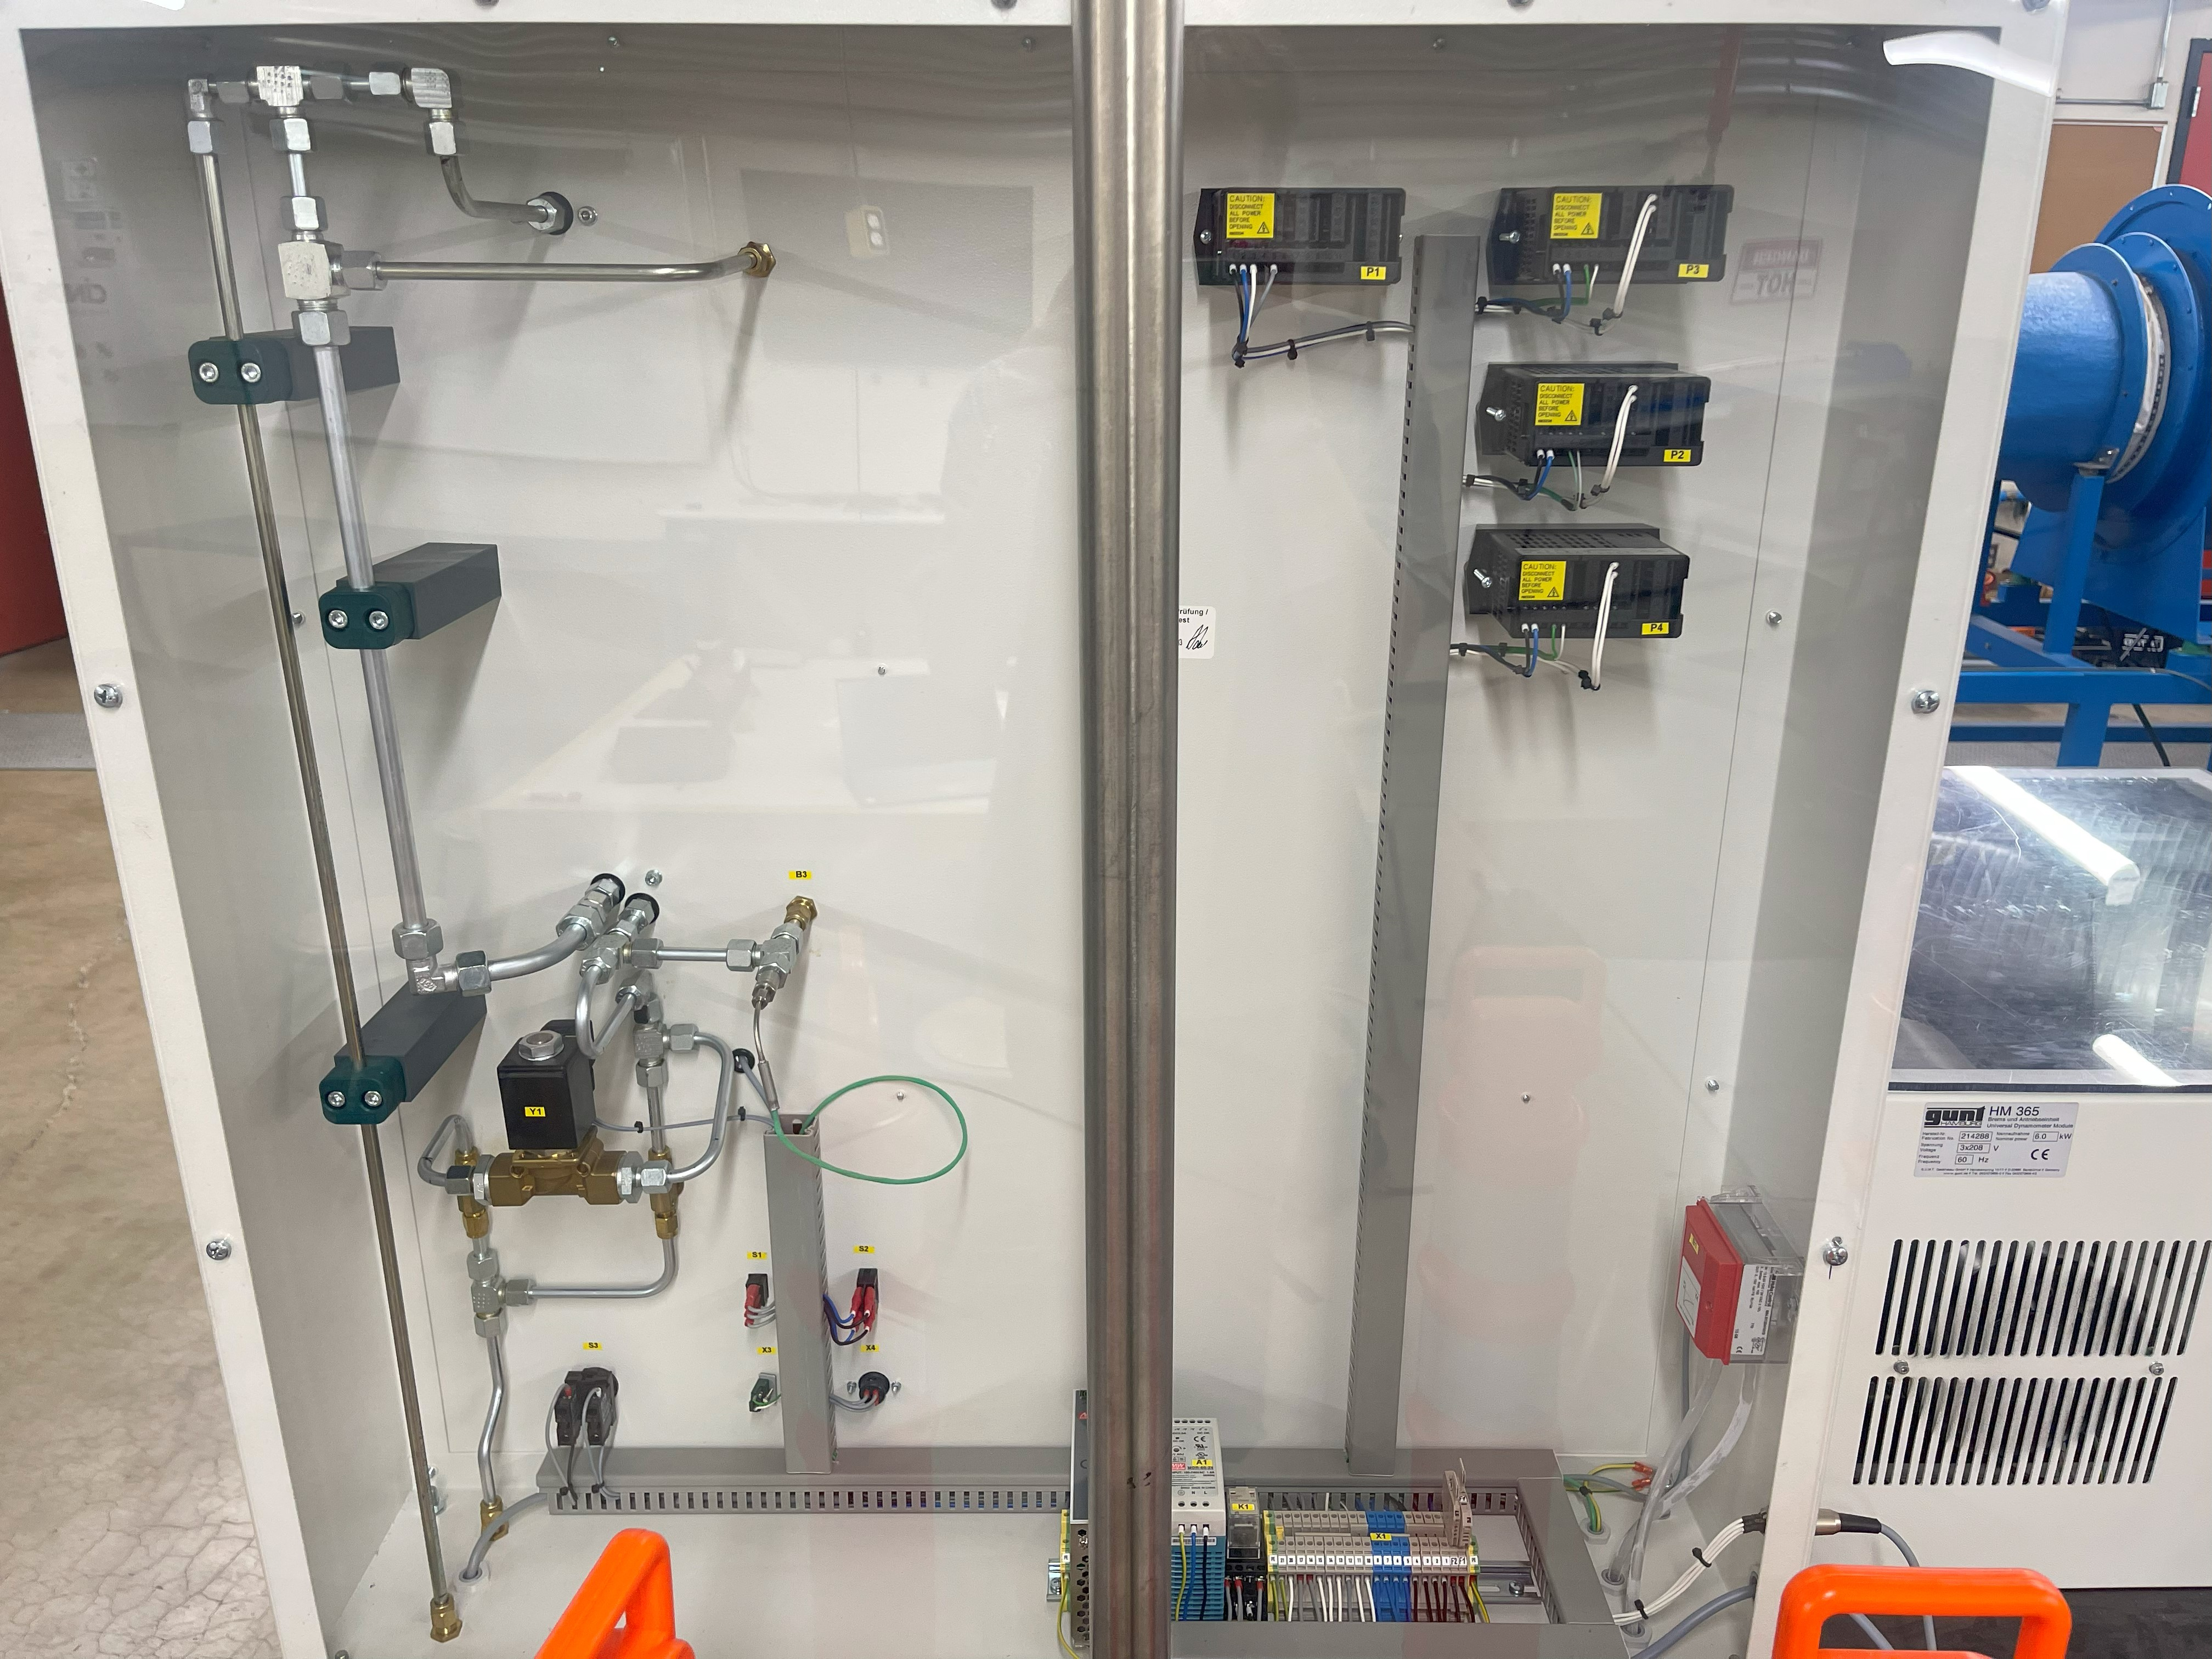

Figure 1: Proper wiring of terminals/displays, acrylic panel for inspection

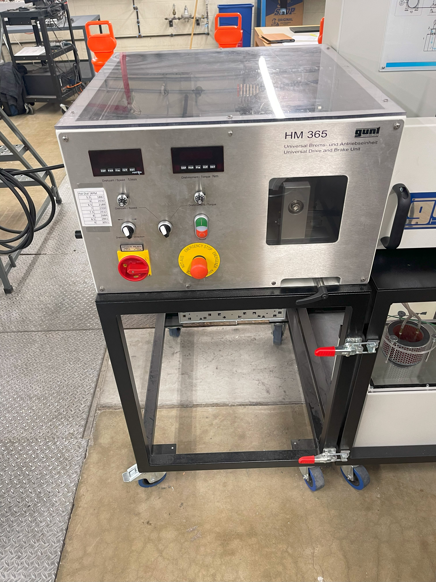

Figure 2: Control panel example with switches, knobs, and buttons from TFES lab

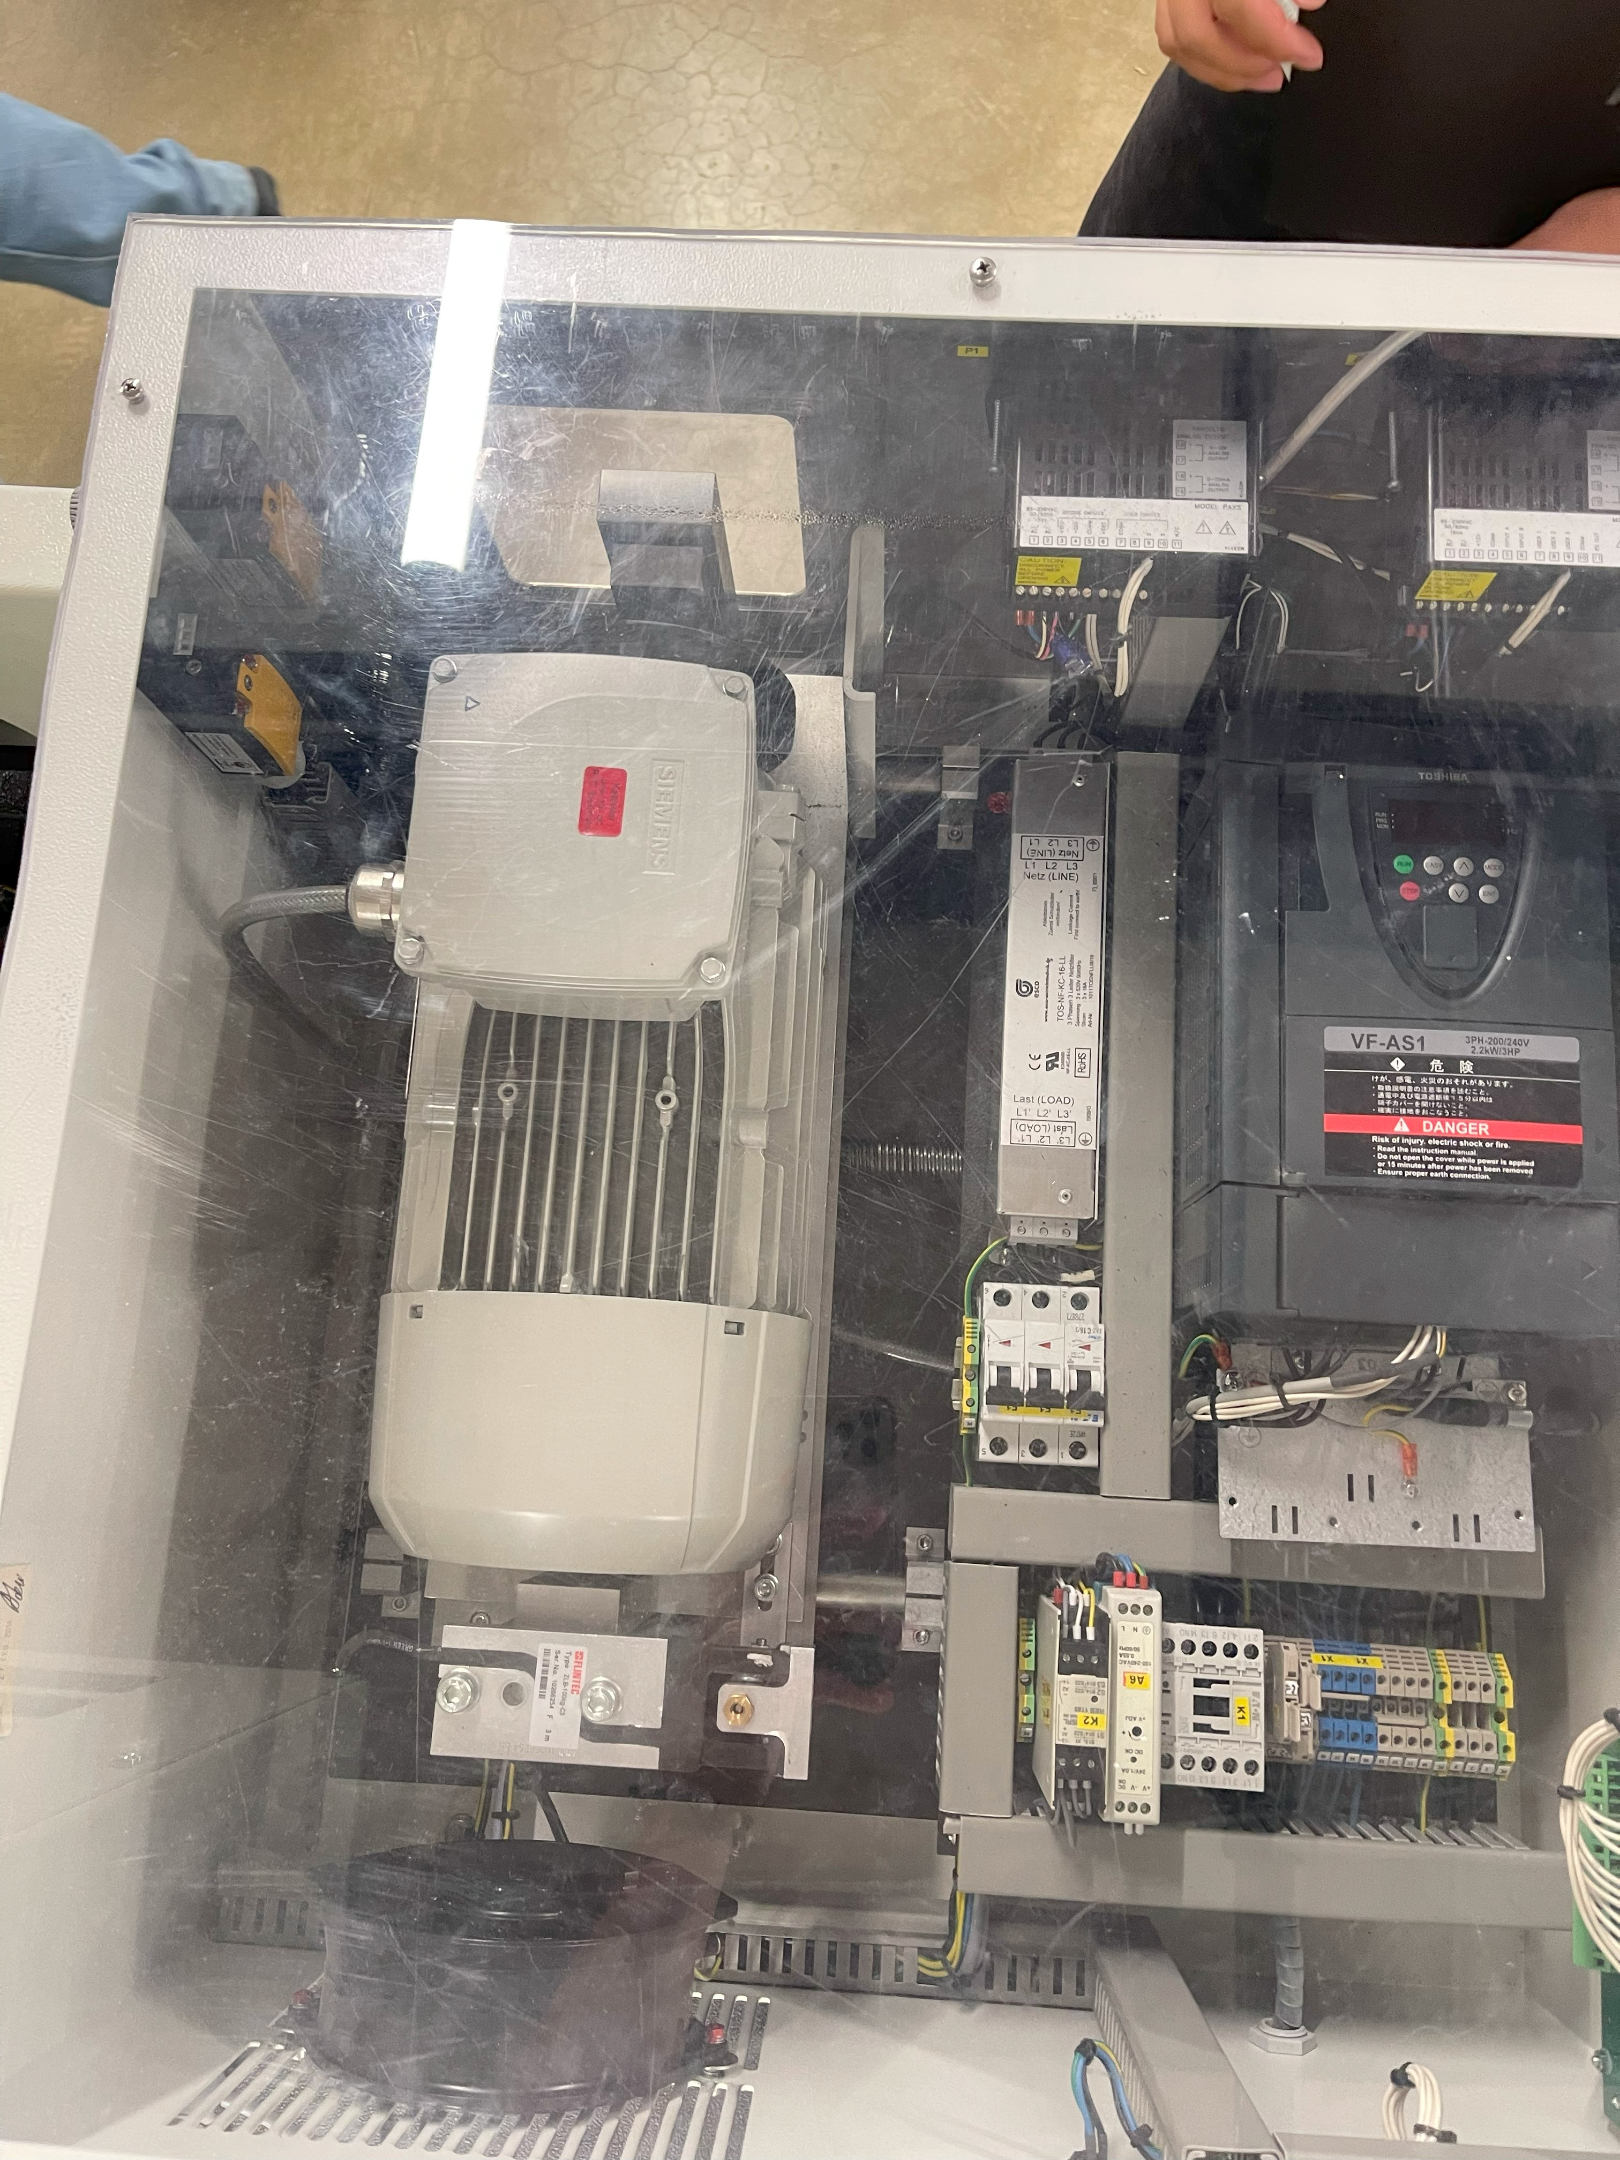

Figure 3: See through panel into a PLC system comprised on a motor, VFD, fuses, and terminal connections

User Needs Testing Notes

* Students will be working in the old machine shop in MEB.
* The allotted volume per workspace for each trainer platform will be 36 inches x 24 inches x 18 inches.
* One power cable is allowed for this system, multiple will lead to safety issues.